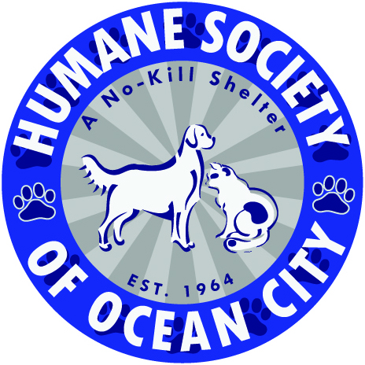
Saturday May 15th live from Ocean City Skatepark in beautiful OCNJ
$20 entry fee(registration before 5/10/21 guarantees event t shirt) Size : S M L XL
Ocean City Recreation Division-SKATO with KATO 2021 -Event Registration and Waiver

Contest starts @ 5:30 pm…..Allskate purrformance by LNJ SESSIONS @ 4:30 pm

Contestants Name:____________________________________________________________

Age::__________ M:_______ F:______ DOB:_____________ Level__________________

If under age 18 please provide information for parent/guardian

Name:_______________________________________________________________________

Address:____________________________________________________________________

Phone:______________________________Email:___________________________________

PARTICIPANT WAIVER
In consideration of you accepting my entry, I hereby, for myself, my child, my heirs and administrators, waive and release any and all rights and claims for damage, I or my child may have against The Humane Society of Ocean City, The City of Ocean City or School District or any of it’s representatives or successors for any and all injuries suffered by myself or my child at this and any activity sponsored by these groups.

Signature:_______________________________________________ Date:_______________
*Parent or guardian signature if under 18 years of age

All proceeds raised will benefit the cats and dogs of the Humane Society of Ocean City Animal Shelter/Adoption Center with .93 cents of every dollar raised going directly to help the animals in their care and their mission to enrich and save lives.

Have additional questions or need more deTAILS? email phil.bellucci@hsocnj.org

www.hsocnj.org
609-398-9500 x4

