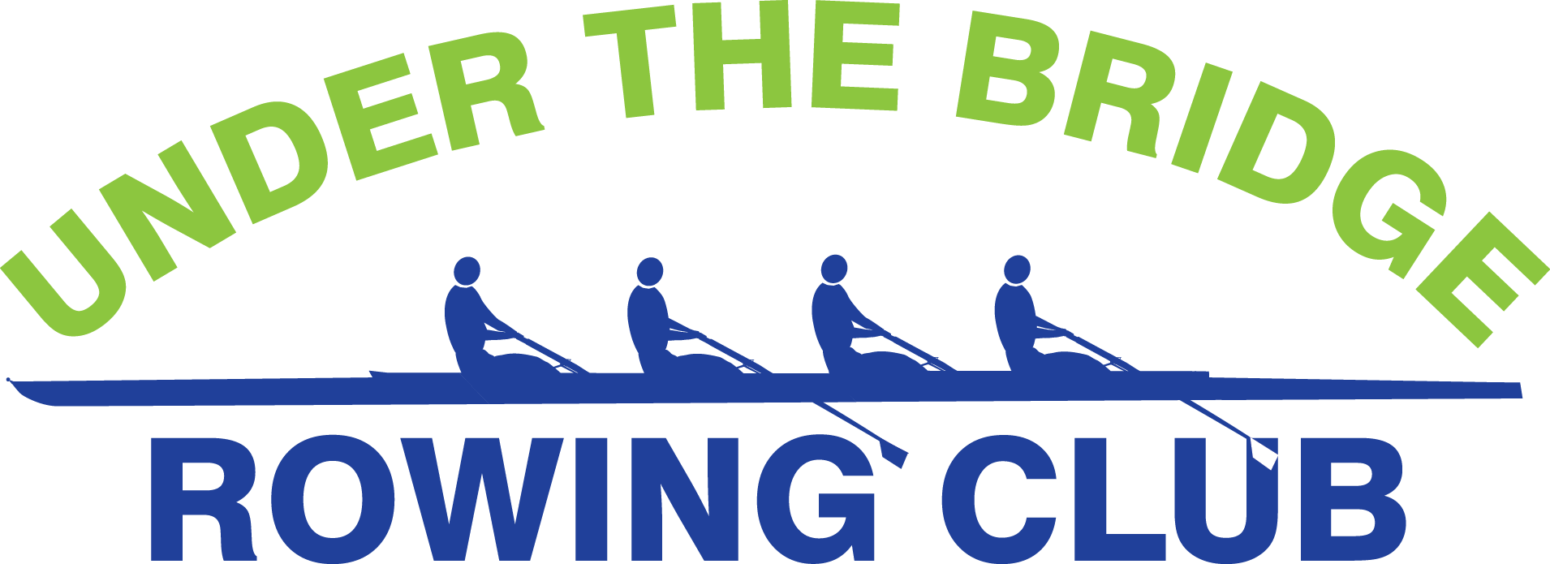

“CREWZAPALOOZA” BEEF & BEER BASH
LA COSTA LOUNGE, SEA ISLE CITY
SATURDAY, FEBRUARY 3rd
6 PM to 9 PM
Tickets are $25
Includes buffet & house wine, beer and soft drinks
Live music by classic rock band, Suzé & Ultraviolet
For more information or to purchase tickets,
call 609-287-0646.
Or visit Positively 4th Street Café, Ocean City, McMahon Insurance Agency, 901 Simpson Avenue, Ocean City.

