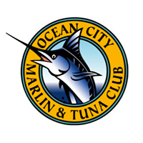OCMTC OVERNIGHT SWORDFISH TOURNAMENT/
OVERNIGHT BILLFISH TOURNAMENT CHAMPIONS

1978 SERENA 1991 PIPE DREAM 2004 RAPTOR
1979 DITCH DIGGER 1992 CONQUEST 2005 VIKING 68
1980 CHRISTI 1993 SCRAPPY 2006 SEA MISTRESS
1981 DITCH DIGGER 1994 HARRY II 2007 VIKING 68
1982 WOOD JU PAT 1995 FISHERMAN JOE 2008 COVERT MISSION
1983 PILL ROLLER 1996 HARRY II 2009 ANTHRACITE
1984 LUCKY LINDA 1997 SANTA CLARA 2010 ANTHRACITE
1985 WEKETCHEM 1998 CANCELLED 2011 CHANGE ORDER
1986 CANCELLED 1999 BUSTING LOOSE 2012 VIKING 70
1987 WOODSHED 2000 MY TIME 2013 TRUST ME TOO
1988 NICE AND EASY 2001 THE SHARK 2014 POLARIZER
1989 PRIME TIME 2002 SEA MISTRESS 2015 CAPTAIN CHAZZ
1990 AN ESTHETIC 2003 AQUA AZUL 2016 OH WELL

