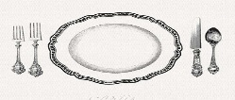
Thursday November 17, 2016
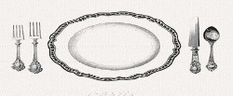
Please join us at the
11th Annual OCHS Scholarship Dinner
Located at OCHS Cafeteria 5:00-7:00 pm
prepared by favorite local chefs!

To purchase tickets or request more information
e-mail Amy Kohl akohl@ocsdnj.org

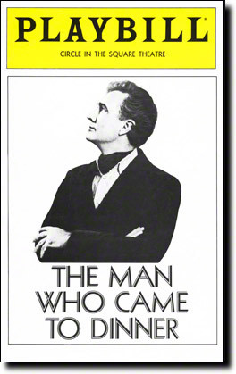
After dinner, enjoy the performance of
The Man Who Came to Dinner

