Back to School already?!? Say it isn’t SO! …… Grab the whole family and make the most of an Endless Summer at Wonderland … Spread the word to your neighbors and friends!

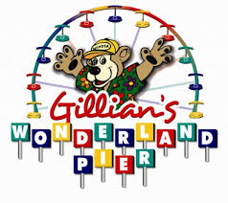

$20 Unlimited Ride Wristbands

Saturday, September 17th ⁻ 1 - 4 pm *

Gillian’s Wonderland Pier - Sixth Street at the Boardwalk

Purchase wristbands at front ticket box by Carousel
Special Guest Appearances at the Dunk Tank - $1/ball

Proceeds benefit
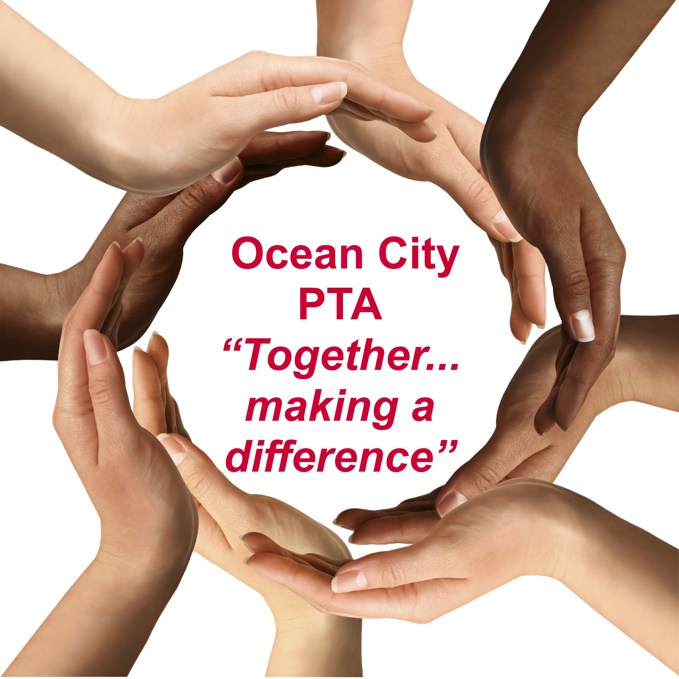

* Rain Date Sun, 9/18 1-4pm
Questions? Please contact Sarah McDowell at 609.425.8844 or sarahmcdowell@comcast.net

